**What is Jungle Mania(plot)?**

Jungle Mania is an arcade survival game. It was designed to create a 2D open world that was out to get the player. The game follows a narrative where three evil scientist set out to create the perfect creature to rule the animal kingdom. After years of exertion and research, the player, 'Specimen 97' is their grandest creation, the one they believe to be fit for to rule the jungle, hence initiating the Jungle Mania. The player is plunged into a world of many dangerous terrains and a large assortment of vicious unique enemy types scattered throughout, it's a jungle out there! The player's main goal is to stalk his prey, feed himself to grow into the ultimate predator, level up his skills to make life easier, and in due course survive as many days in the jungle as possible. To stimulate the game's survival element, the player has but one life. Losing it leads to restarting the game.

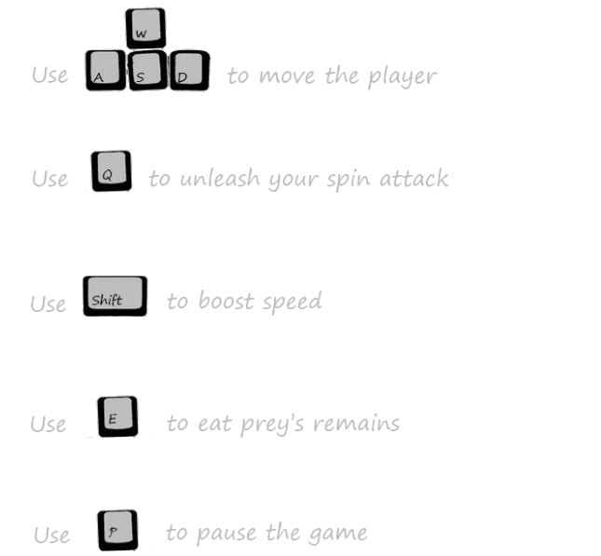**General Game Controls**

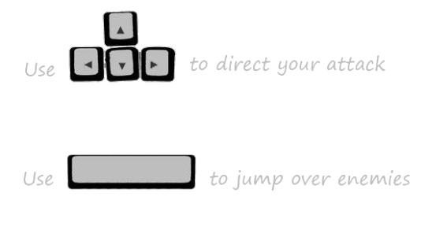

**How is Jungle Mania Designed?**

The game is designed to test your strategic and survival skills. Designing the game to maintain this challenge required the implementation of multiple mechanics. The first mechanic is the hunger mechanic. The yellow bar at the top left of the screen is the hunger bar.

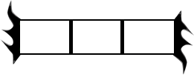

the fuller the bar is the hungrier the player animal is. The hungrier the player is, the more their health will begin to decay. The player is health is displayed with the red equivalent of the hunger bar. The only way the player can satisfy his hunger is by eating the remains of his victims, the player can do this by eating the corpse sprite, below.

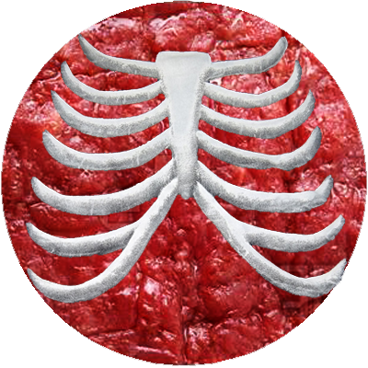

This increases the difficulty of the game because eating takes time, once the player has killed an enemy, he must hold the 'E' key to eat the remains. This task would be difficult to complete if the player is fending off against many animals, or being hunted by bigger animals. So the player will have to be careful as to where he decides to deliver the killing blow on his enemy to ensure a few safe moments as he devours the remnants to satisfy his hunger.

The second mechanic is the time of day mechanic. The main goal behind implementing this mechanic was to create a observable way for the player to track his progress of surviving through a day. After nightfall strikes the player knows he has now finally begun approaching the half way point of surviving a day. The other reason the night-day mechanic was implemented was to enforce the element of danger and survival. When night strikes the game screen get extremely dark in comparison to the day (as seen in the images below), making harder to see. At night it is much harder to differentiate between enemy types, harder to keep track of where you are going, and most of all harder to indentify how many enemies are surrounding your position. The player is forced to be become more cautious during the night. As the days the player survives progress, the total population of enemies will increase. So besides surviving a day, the player is also pressured to collect as much XP as possible and level up fast so he is more prepared for the larger swarm of enemies he will encounter in the future.

**Day:**

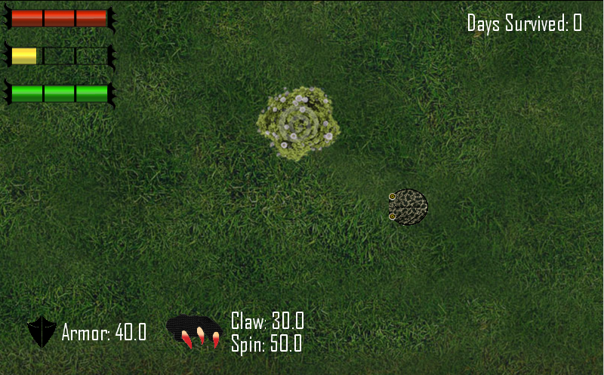

**Night:**

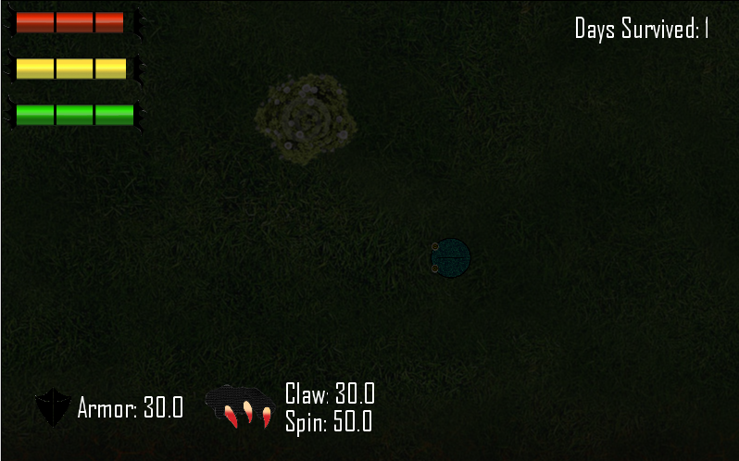

The third survival mechanic is animal diversity. The game contains 5 different main enemy types. Each type comes in an assortment of sizes, each enemy size deals a different amount of damage and health variable. This trait is a resultant of written code the calculates the enemy's traits based on their size. The real reason the larger enemies are more of a threat is their reach, the larger enemies have a large collision surface area, therefore it is harder to manoeuvre around a group of them than it would be dodging smaller ones. The first of the 5 archetypes are the grass animals.

The grass animals, are the base enemy class in the game. The player starts the game in the grassy terrain, where he will immediately encounter these. The grass animals have a balanced armour, speed, and health (which vary depending on the specific animal size). They begin to really pose a threat to an experienced player once they attack in packs. This enemy type was designed to create a challenge to a new player and a source for a quick snack for a more experienced player.

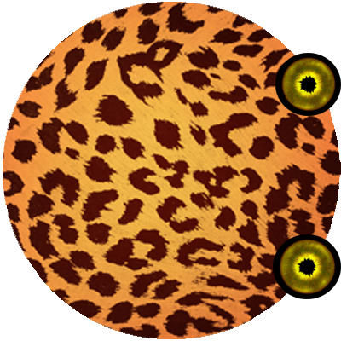

**Recommended Grass Animal Tactics:**

* At first be constantly on the move, use trees and other obstacles to put space between you and them.
* Thin out their numbers by escaping their aggro range.
* After levelling up, it is best to round a couple of them up and attack the group creating a large feast pool to return to when hungry.
* Be wary! Attempting to use the above tactic during the 1st level will most probably fail, their speed and damage intensity are too high in comparison to the player's health and speed. The player will be outmatched and outnumbered every time, unless the first tactic is applied.

The Second enemy archetype are the lava animals:

The Lava animals are significantly larger than all the other animals in the game world. Since they're larger, the sand animals move slower than all other animal types in the game, however, they deal an incredibly large amount of damage. The Lava animals are cowards despite their large size! Once the player manages to prove his might hold his own against them wearing their health down, they will immediately flee the scene. They enter this behaviour for as long as they live. The exact enemy that encounter the player will always flee his presence for as long as he remains alive! This makes it extremely hard to kill them, which counteracts the large amount of XP the player receives for killing them.

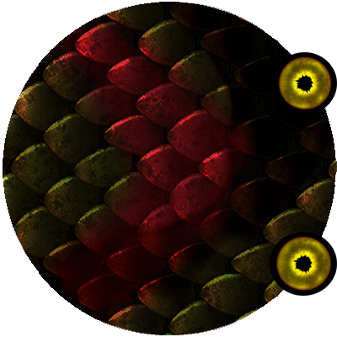

**Recommended Sand Animal Tactics:**

* Do not attack them at a low level, they will deal an incredible amount of damage and due to their slow nature, draw you in to make a move and then overwhelm you.
* Corner them before lower their health too low, this ensures that they have little to no place to run to after they become afraid of you.
* If you are a player with a level up tee focused on speed, it is best to go after these enemies, since it will be easy to catch them when they flee and they reward you with a large quantity of XP.

The third enemy Archetype is the rock animals:

The rock animals are the fastest and smallest of the 5 types in the game. They are extremely fast but deliver a slightly less amount of damage than the others. They will follow the player across the entire map. making it increasingly difficult for the player to get away from an encounter with one of them. They live in a secluded part of the game world where a river blocks them off, once the player enters their territory, the only way out is the way he came in.

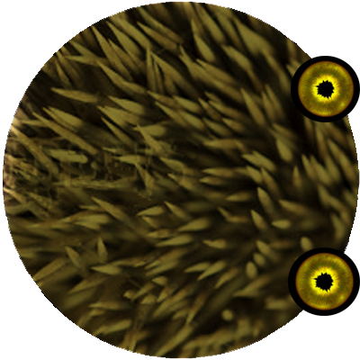

**Recommended Rock Animal Tactics:**

* Approach them only if the player is at a high level with either a large amount of armour: to sustain their rapid attacks, a large amount of power: to kill them off quickly before too much damage has been absorbed, or a speed to match theirs.
* It will indefinitely take the player an extremely long amount of time before he can match their speed, therefore, it is probably not wise to rush into fighting them.
* Use boost to quickly navigate of the territory when needed!
* Using the spin attack when you are surrounded by them, it will cause a large knockback that gives the player a window to make create distance between you and them.
* Since these enemies are extremely fast and dangerous to a new animal, the game world has been made in a way to maintain balance, the player should use the river as a means of ensuring safety from the animals whenever they begin to attack.

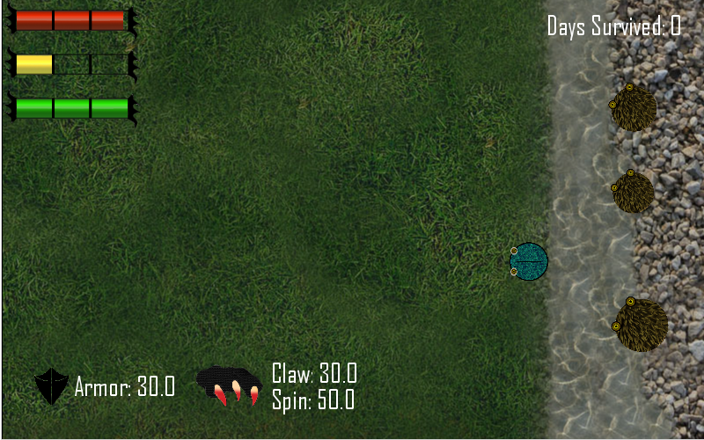

The fourth enemy Archetype are the Snow animals:

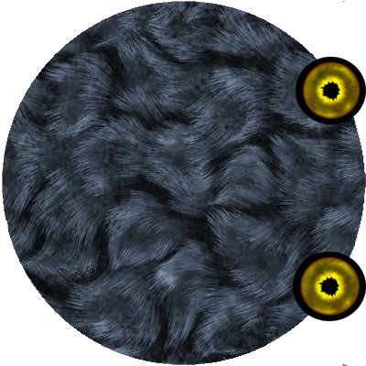

The snow enemies are amongst the most vicious roaming the entire jungle. They contain an average amount of damage, health, and speed. But the ability to pounce is precisely what makes them extremely dangerous to an unsuspecting player. Before attacking, the snow animal will take a moment to step back and target its prey, and ferociously pouncing across the screen to attack! Since they are also contained within the walls of a large hedge, they often not hunting the player. However, should he choose to tread around them, they are liable to leave their snowy home and follow the player. The snow animals also tend to be spawned in packs, so even if one is dodged, the next will already be in the air righting the last's failed attempt.

**Recommended Snow Animal Tactics:**

* The snow characters can be dealt with early on in the game if the player is coordinated. Watching carefully for when the animal begins to prepare for its pounce; the player can use boost to dodge the attack and launch his own before the enemy has time to recover.
* Having a large amount of speed makes it extremely easy to dodge the snow animals, and it becomes a game of tag whenever they are near.
* Similar to the rock animals, it is wise to draw them thin then out manoeuvre them and go for the kill.
* The easiest way to ensure a successful hunt against a snow animal is to have extremely high armour and walk in their hedge snow how and slaughter them without care, this is only possible because they do not necessarily posses a large amount of health.

The final enemy Archetype are the Lava animals:

The lava animals, are the endgame creatures. They have the strongest ability of all the animals, suicidal tendencies! They are animals that are easily alerted by your presence, and should you be spotted by them, they will rush to attack you. Once in contact with the player, the Lava animal will directly explode, dealing a devastating amount of damage that is certainly fatal to a low level player. There exists a few Lava enemies in the game world at the beginning, they lurk deep down in the lava territory. While they are extremely dangerous, the Lava animals are the most fragile of the bunch, one simple attack from even the lowest skilled player will result in a nice meal, and an enormous batch of XP, should you be so lucky.

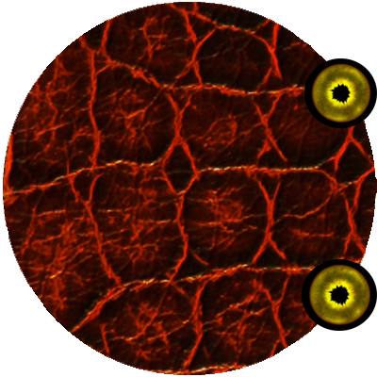

**Recommended Lava Animal Tactics:**

* Caution! The most important thing when treading the lava lands, is to ensure that you are not moving too fast, it is a huge advantage knowing exactly where the Lava animal is before they know where you are.
* The immediate second the lava enemy begins to peruse you, unleash your spin attack to catch them before they catch you.
* As a safety net for failure to defend against their attack, it is best that a player with high armour value attempt to confront them, to out run them or use boost would require an extremely large speed level.
* Seeing as they are extremely fragile, power means nothing when confronting a lava animal, therefore it should not be taken into account when preparing to fight them.

**The Player**

The player assumes the control of Specimen 97 who starts of as a tiny creature. The more he eats and kills his prey, the larger his experience bar gets! After accumulating a certain amount of XP, the player levels up! There are three key evolutionary phases, each marked by their own unique player skin. Once the player evolves to a new phase; a special game sound plays to alert him! The key phases are illustrated below:

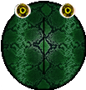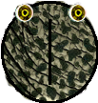

The different phases don't hold any significance besides rewarding the player aesthetically for his progression through the game. Each evolution phase holds about three levels in between. Once the player evolves past the third level of the final phase, his skills will outmatch all of the other animals in the entire game. At this point he will have truly become king of the jungle.

 Through the game the player has two ways of attacking at his disposal; the normal directional attack, and the spin attack. The spin attack yields more damage to its victims and also causes a larger knockback! But with great power, comes great responsibility. The player also has a stamina bar that is depleted when he uses any of his attacks or boost. The stamina bar ensures that the player does not spam attack the enemies and enforces balance in the game. The stamina bar, is the green bar located at the top left of the screen.



**Choice**

Goals, Clarity, Progression, variety of encounter, and resources are all outlined through the games mechanics and story. The element of choice is stressed through the openness the game presents to the player. Besides the obvious choice of being able to go wherever he wants, which comes with almost every open world game, the player also has choice in the way he wants to play the game. The tactics the player chooses to implement are not limited by the game mechanics. As seen previously, when the player levels up, he is given a choice of three different attributes that he can increase. There are many different combinations that will immensely alter game play. Should the player choose to progress through the speed route; he will be able to waltz in and out of zones with incredible ease, ambushing prey and avoiding predators. Should the player choose to progress his attack skills; even the heaviest armoured animals will become a quick kill, a smooth enough player can neutralize any threat before they begin to cause him harm. Should he choose to progress the armour value; the player can tread without fear and worry of what will jump out at him next! It becomes a stress-free environment which allows for tactic experimentation without the fear of dying and restarting.

On top of the progression trees, the player also has access to many abilities that he can use in any way possible. For example, the player can dodge many enemies differently depending on his motives. Should he want to dodge and immediately strike back, he can time a jump perfectly to avoid taking damage and then throw his own attacks. If the player plans on escaping, he can use boost to make a quick narrow escape and flee from battle. The method of play and tactics are entirely in the hands of the player. This is the main choice that Jungle Mania offers, and is arguably the only game changing one.

**Leveling Up!**

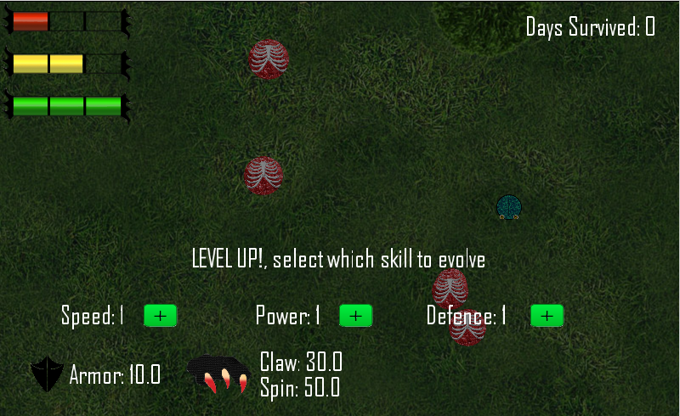

As the player progresses through the game, through the act of slaying enemies, the player will accumulate experience points (indicative of the yellow bar at the bottom of the game screen). Once the player has reached enough experience points to level up, a level up overlay will be shown on screen (as shown in the above picture), that allows the player to choose between: speed, power and defence. We wanted the game to flow, as the result the game continues even will the level up overlay is active, however if the player is experiencing dangerous situations and needs the level up to stay alive, the player can press the “p” key to pause the game and chose an option. This allows the player to make his choice without the fear of restarting. Choosing an option fully restores the player’s health and stamina levels. Choosing speed will increase the players speed, stamina, as well as the player attack speed (claw and spin attacks will be faster). Choosing power will increase the player’s damage for both the claw and spin attack (shown at the bottom left of the screen, as well as the player size by a margin. Choosing defence will increases the players armor (shown at the bottom left of the screen), health, as well as the players size (directly relates to the size of the claw and spin attack). To show the player has increased in size, we have added different sprites for the creature, which are automatically used instead of the previous sprites when the player reaches certain sizes and a growl sound affect is also played to emphasize the player’s evolvement. The different level up choices are given so the player has full control over the progress of the creature and can truly play the game their way. For example, speed will allow players to doge enemy attacks and kite them around, power will allow the player to quickly kill the enemies and defence will allow the player to tank a lot more enemy hits.